Join our MOOC
Language Testing During Awake Brain Surgery
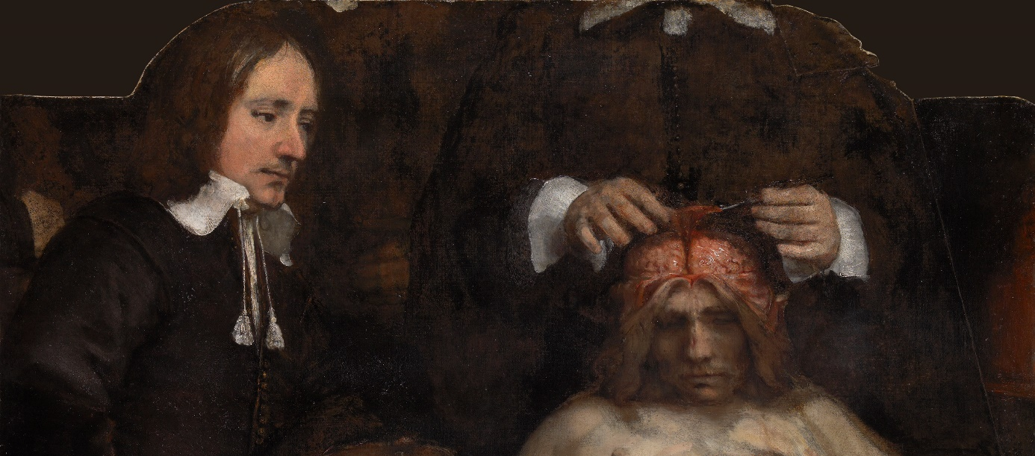
On October 1st, 2018, the MOOC Language Testing During Awake Brain Surgery will begin. The online course focuses on the relevance of language research during waking brain operations, and the complexity of language representation in the brain. Registration is free and can be completed via the website FuturLearn.com.
During awake brain surgery, the representation of language in the brain can be examined using language testing. Participants of the MOOC are educated on how to develop such language tests, as well as the latest developments in this field. Topics covered include neuroanatomy, language presentation in the brain, brain tumors, language tests and neurotechnology.
The online course was developed by Professor Dr. Roelien Bastiaanse. Roelien Bastiaanse works in the Department of Neurolinguistics at the Faculty of Arts and the University Medical Center Groningen (UMCG), as well as at the Higher School of Economics in Moscow. The course lasts six weeks and is available to anyone who is interested in these topics. Registration is free and can be completed via the website FutureLearn.com.

